Martha Sandy, Ph.D.

Chief, Reproductive and Cancer Hazard Assessment Branch

Office of Environmental Health Hazard Assessment

Submitted via: <https://oehha.ca.gov/comments>

October 11, 2022

RE: Comments on No Significant Risk Level (NSRL) for antimony trioxide

Dear Dr. Sandy,

On behalf of the undersigned scientists and health care professionals, we appreciate the opportunity to comment on the No Significant Risk Level (NSRL) for antimony trioxide proposed by OEHHA on August 26, 2022. The proposed NSRL will be useful for guiding businesses and the public on whether warnings may be required for workers or consumers who may be exposed to antimony trioxide, a substance listed as known to cause cancer under Proposition 65. The specific proposed NSRL of 0.13 micrograms per day (μg/day) is based on an appropriate study and calculated according to the established scientific methodology described in Title 27, Cal. Code of Regulations, Section 25703. For these reasons, we support finalization of the proposed NSRL.

**Background**

Proposition 65, the Safe Drinking Water and Toxic Enforcement Act, was enacted as a ballot initiative in November 1986.[1] This law protects California drinking water from contamination with chemicals known to cause cancer, birth defects or other reproductive harm, and requires businesses to inform consumers and the public about exposures to these chemicals. As the implementing agency, OEHHA has the responsibility to maintain the list of chemicals known to the state to cause cancer, birth defects or other reproductive harm. OEHHA is also charged with developing so-called “safe harbor” levels, below which no warning is required. In the case of carcinogens the safe harbor, or NSRL, must be set at a level that poses a one in 100,000 risk of cancer (10-5).[2]

Antimony trioxide was listed as known to the state to cause cancer on October 1, 1990. Although the original listing was based on a determination by the International Agency for Research on Cancer (IARC), the National Toxicology Program (NTP) subsequently determined in its Report on Carcinogens in 2018 that “Antimony(III) trioxide is *reasonably anticipated to be a human carcinogen* based on sufficient evidence of carcinogenicity from studies in experimental animals and supporting data from mechanistic studies.” [3] Had the substance not already been listed, the NTP determination would have been sufficient to trigger a cancer listing because NTP has been found to be authoritative by the Carcinogen Identification Committee (“State’s Qualified Experts”).[4] There is consensus among authoritative agencies that supports the cancer determination for antimony trioxide based on animal evidence and mechanistic information.

**Basis of the Cancer Slope Factor is Scientifically Sound**

OEHHA relied on the 2017 National Toxicology Program (NTP) technical report entitled “Toxicology and Carcinogenesis Studies of Antimony Trioxide (CAS No. 1309-64-4) in Wistar Han [Crl:WI (Han)] Rats and B6C3F1/N Mice (Inhalation Studies)”[5] and the 2018 NTP Report on Carcinogens Monograph on Antimony Trioxide.[6] The NTP technical report and the NTP Report on Carcinogens (RoC) monograph summarize the data from rodent carcinogenicity studies performed by NTP and others, as well as other in vitro and in vivo testing relevant to the carcinogenic activity of antimony trioxide. NTP’s Level of Evidence Conclusion on the animal carcinogenicity testing was: “Sufficient evidence of carcinogenicity from studies in experimental animals based on the combined increase in the incidences of malignant and benign tumors at several tissue sites in rats and mice”.[7]

Antimony trioxide caused alveolar/bronchiolar carcinomas in both sexes, and caused a variety of other cancers, including fibrosarcoma in male mice, and malignant lymphoma in females. The rates in the exposed animals compared to controls were highly significant, with clear evidence of a dose-response relationship.

The derivation of the cancer slope factor (CSF) based on the recent 2017 NTP study in B6C3F1/N mice is appropriate because of the quality of the study and the fact that it was conducted according to current scientific methodology. Specifically, the selected study scored highly for study design (e.g., randomization, concurrent controls, statistical power, etc.); exposure (e.g., chemical characterization, dosing regimen, exposure duration, etc.); outcome assessment (e.g., methodology, consistency, etc.); considerations of confounding; and analysis/reporting.[8] It is also appropriate to select the 2017 study because the NTP is an authoritative body designated by the Carcinogen Identification Committee, so selection of an NTP study is the most scientifically defensible approach to derivation of the CSF.

**The Presence of Genotoxic Effects Requires Use of a Linear Multistage Model**

As noted in the OEHHA Initial Statement of Reasons and the NTP 2018 Report on Carcinogens, antimony trioxide is electrophilic, can cause oxidative stress both in vitro and in vivo, inhibits DNA repair, causes oxidative damage, and appears to decrease cell differentiation. Numerous studies show that antimony trioxide inhibits cellular antioxidant defenses and interacts with nucleic acids and proteins. Antimony trioxide causes DNA and chromosomal damage, both in vitro and in vivo. All of these findings are recognized to be key characteristics of carcinogens, and these mechanisms of action are relevant to carcinogenesis in humans.[9]

OEHHA also notes correctly that there is evidence that antimony trioxide has multiple carcinogenic mechanisms of action, and it exhibits evidence of DNA damage in multiple assays (e.g., mouse lung *in vivo* DNA damage, chromosomal aberrations *in vitro*, micronucleus formation *in vivo*, and sister chromatid exchange *in vitro*). Figure 6-2 from the NTP Report on Carcinogens (see below) illustrates some of the multiple mechanisms by which antimony trioxide likely causes cancer.[10] These effects are all biologically plausible and relevant to humans. The clear presence of genotoxicity as one of the mechanisms of action makes OEHHAs choice of a low dose linear assumption both appropriate and necessary.

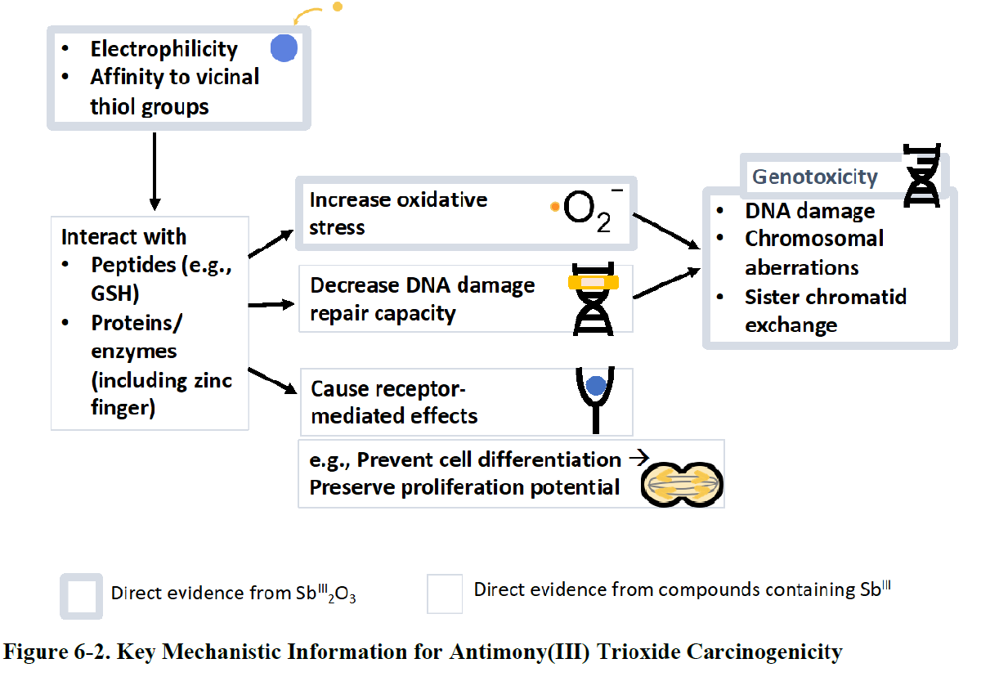

**Using Inhalation Studies to Derive an NSRL is Appropriate**

Antimony trioxide increased the incidences of malignant tumors or combined malignant and benign tumors at two tissue sites in rats (lung and adrenal gland) and three sites in mice (lung, skin, and lymphoid system). It is important to note that cancer sites outside the lung were identified in both species. OEHHA’s use of tumors in female B6C3F1/N mice is appropriate for derivation of the CSF, especially because these female mice developed tumors in multiple sites, including lung alveolar/bronchiolar adenoma or carcinoma and malignant lymphoma. It is standard practice to extrapolate across various portals of entry to derive the NSRL, especially for substances such as antimony trioxide that have clear systemic evidence of carcinogenicity.

For all of the above reasons, the proposed NSRL is correctly calculated and should be finalized in Title 27, California Code of Regulations, section 25705(b).

Thank you for considering these comments.

Sincerely,

Gina M. Solomon, MD, MPH

Clinical Professor of Medicine,

University of California San Francisco, CA

and

Bruce Lanphear, MD MPH

Professor, Health Sciences

Simon Fraser University, Vancouver, BC

Leonardo Trasande, MD, MPP

Jim G. Hendrick, MD Professor of Pediatrics

Director, NYU Center for the Investigation of Environmental Hazards

Division Chief, Environmental Pediatrics & Vice Chair for Research in Pediatrics

Professor of Environmental Medicine & Population Health

NYU School of Medicine, New York, NY

Ann Blake, PhD

Founder and Principal

Environmental & Public Health Consulting

Alameda, CA

1. Health and Safety Code, Division 20, Chapter 6.6. Safe Drinking Water and Toxic Enforcement Act of 1986 [25249.5 - 25249.14].
2. Title 27, Cal. Code of Regulations, Section 25703.
3. National Toxicology Program (NTP 2018). Report on Carcinogens Monograph on Antimony Trioxide. RoC Monograph 13. US Department of Health and Human Services, NTP, Research Triangle Park, NC. Available from https://ntp.niehs.nih.gov/ntp/roc/monographs/antimony_final20181019_508.pdf.
4. https://oehha.ca.gov/proposition-65/how-chemicals-are-added-proposition-65-list
5. National Toxicology Program (NTP 2017). Toxicology and Carcinogenesis Studies of Antimony Trioxide (CAS No. 1309-64-4) in Wistar Han [Crl:WI (Han)] Rats and B6C3F1/N Mice (Inhalation Studies). NTP Technical Report Series No. 590. US Department of Health and Human Services, NTP, Research Triangle Park, NC. Available from https://ntp.niehs.nih.gov/go/tr590.
6. National Toxicology Program (NTP 2018). Report on Carcinogens Monograph on Antimony Trioxide. RoC Monograph 13. US Department of Health and Human Services, NTP, Research Triangle Park, NC. Available from https://ntp.niehs.nih.gov/ntp/roc/monographs/antimony_final20181019_508.pdf.
7. Ibid, p. 76.
8. Ibid Table 5-2, p. 69.
9. Smith MT, Guyton KZ, Gibbons CF, Fritz JM, Portier CJ, Rusyn I, DeMarini DM, Caldwell JC, Kavlock RJ, Lambert PF et al. 2016. Key characteristics of carcinogens as a basis for organizing data on mechanisms of carcinogenesis. Environ Health Perspect. 124(6):713-721. <http://dx.doi.org/10.1289/ehp.1509912>
10. NTP Report on Carcinogens, 2018, p. 96.